**Windesheim**

Campus 2

Value Chain Rebels

**Jan 29, 2024**

Contents

2. Introduction 5

Purpose of the Action Plan 5

Scope of the Organization 5

3. Executive Summary 6

4. Mission Statement and Objectives 7

5. Background and Rationale 8

6. Organizational Structure 9

7. Leadership and Governance 10

8. Teams and Departments 11

9. Strategic Plan 11

Long-Term Vision 11

Strategic Objectives 11

10. Operational Plan 12

Daily Operations 12

Resource Management 12

Process Management 12

11. Budget and Financing 13

Financial Planning 13

Financing Strategies 13

12. Risk Management 14

Risk Analysis 14

Mitigation Strategies 14

13. Marketing and Outreach 15

Target Audience Definition 15

Marketing Strategies 15

Communication Plan 15

14. Evaluation and Improvement 16

Success Metrics 16

Feedback Mechanisms 16

15. Employee Feedback & Action 17

Feedback Collection Analysis 17

Feedback into Action 17

16. Research and Development (R&D) 18

Research Objectives 18

Research Process 18

17. Academic Programs and Curriculum 19

Program Development 19

Teaching Methods 19

18. Student Affairs and Mentorship 19

Student / member Wellbeing 19

Group Activities 19

19. Staff Policies and Faculty Development 20

Recruitment and Retention 20

Professional Development 20

20. Compliance and Regulations 21

Legal Compliance 21

Regulatory Strategies 21

# Introduction

Placeholder

## Purpose of the Action Plan

Placeholder

## Scope of the Organization

Placeholder

# Executive Summary

Placeholder

# Mission Statement and Objectives

## VISION

PENDING POLL

### Mission

"**Evolutionize** global supply chain dynamics by adding extra value in sustainable or good practices, ensuring that every link in the chain not only benefits economically but also contributes positively to the environment and society.

It’s not just about building new supplychains, or even to “transform them” it’s to bring them to the next step, the new world; Columbus didn’t discover the world was round, nor did anyone question that, he believed it was economically viable to sail that way, where everyone else thought the distance was just too great. Columbus didn’t convince the royal court that “There is another way to India” but “There might be a more economical way to India, and we would be foolish not to check it out”. History, it’s cool!

### Innovate for Financial Sustainability

Develop and implement cutting-edge technologies and methodologies that reduce waste, lower carbon footprints, and enhance supply chain accountability. It’s not just about finding a mine and then mining it till its all gone, it’s about creating a continuous mine, that will keep providing.

Goal: Launch at least three sustainable supply chain solutions annually that significantly impact environmental preservation and resource efficiency.

### Foster Collaborative Networks

Build a global network of partners including industries, academic institutions, NGOs, and governmental bodies to share knowledge, resources, and best practices.

Goal: Establish and maintain over 50 active partnerships by 2025 to collaboratively work on sustainable supply chain initiatives.

### Educate and Empower

Create educational programs and workshops for businesses, professionals, and students to spread awareness and knowledge about sustainable supply chains.

Goal: Educate 10,000 individuals by 2028 through our programs, creating a knowledgeable community that champions sustainability.

### Drive Economic Viability

Demonstrate that sustainable supply chains are not only environmentally beneficial but also economically advantageous for businesses.

Goal: Provide comprehensive case studies and reports that showcase the economic benefits of sustainable practices in supply chains, leading to a 20% increase in adoption among targeted industries by 2028.

Create chains from mere transactional pathways to transformative forces for global well-being.

# Background and Rationale

Placeholder

# Organizational Structure

# Leadership and Governance

Placeholder

# Teams and Departments

Placeholder

# Strategic Plan

(“Hoe creeren we impact met studenten?”)

(“> Wat we voor ogen hebben om te om de Supplychains te veranderen (Met studenten)”)

Core Objectives:

Strengthening Collaboration for Systemic Impact: Building a dynamic network of partnerships across academic, industry, governmental, and non-governmental sectors to amplify the adoption of sustainable practices and influence systemic change.

Empowering Through Education: Creating a comprehensive educational ecosystem that leverages workshops, simulations, and digital resources to equip current and future professionals with the skills and knowledge necessary for implementing sustainable supply chain practices.

Pioneering Sustainable Supply Chain Solutions: Innovating at the intersection of sustainability and profitability, developing research-driven insights and practices that optimize supply chain operations without compromising ethical standards or financial outcomes

Creating Impact

What do we create?

* Reports, Media messages, around better best practises for supplychain, but disguised as financial opportunity.
* Research around sustainable practises
* Workshops & simulations around sustainable adoption (measuring impact)
* Learning material for new members and educational partners.
* Evolution Opportunities: (Projects, Learnings) the coming together of supplychains and companies, grants and or new upcoming laws.
* New Tools: Software and or packages of tools (a process) for implementation.

#### **Sustainable Supply Chain Innovation Hub**

* **Objective:** To establish a premier research hub focused on the innovation and implementation of sustainable supply chain practices.
* **Specific Actions:**
  + Construct a dedicated digital organisation equipped with advanced research and software tools and technologies for sustainable supply chain innovation.
  + **Forge strategic partnerships with leading academic institutions**, industry pioneers, and technology companies to co-create sustainable supply chain solutions.
  + Initiate a series of interdisciplinary research projects aimed at addressing key challenges in sustainable supply chain management, with a clear timeline for development and implementation phases.
* **Performance Metrics:** The launch of the innovation hub, number and scope of research projects undertaken, partnerships established, and demonstrable advancements in sustainable supply chain practices.

#### **Value Chain Rebels Educational Platform**

* **Objective:** To develop a comprehensive educational platform that offers specialized training and certification programs in sustainable supply chain management.
* **Specific Actions:**
  + Design and launch an online learning hub or depository that provides a curriculum encompassing basic to advanced courses on sustainable supply chain principles, analytics, and technology.
  + Collaborate with experts in sustainability, supply chain management, and educational design to ensure course content is cutting-edge, practical, and accessible.
  + Organize quarterly interactive workshops and annual simulation exercises to facilitate experiential learning, enabling participants to apply concepts in real-world scenarios.
* **Performance Metrics:** Number of courses developed, participant enrollment and completion rates, feedback scores on course effectiveness, and impact assessment of learned skills in professional settings.

#### **Toolkit for Sustainable Supply Chain Transformation**

* **Objective:** To create and distribute a comprehensive toolkit that enables businesses to evaluate and enhance their supply chain sustainability.
* **Specific Actions:**
  + Collect digital toolkits that includes assessment tools, step-by-step guides for implementing sustainable practices, and case studies of successful transformations.
  + Offer a series of webinars and live support sessions to assist companies in adopting and customizing the toolkit to their specific needs.
  + Establish a feedback loop with toolkit users to continuously update and improve the resources based on real-world application and outcomes.
* **Performance Metrics:** Toolkit adoption rate, feedback from businesses on usability and impact, number of webinars and support sessions conducted, and documented improvements in sustainability metrics among users.

Implementation Roadmap:

* **Q1:** Launch Value Chain Rebels (VCR) website and social media platforms for visibility and engagement. Begin partnership development with industry and academia.
* **Q2:** Conduct initial workshops on sustainable supply chain practices. Release first set of best practice reports.
* **Q3:** Deploy Sustainable Supply Chain Toolkit pilot in selected industries. Start sustainability impact assessments.
* **Q4:** Evaluate toolkit pilot outcomes and refine based on feedback. Host year-end conference to share insights and expand network.

**Year 2:** Expand research and partnerships, enhance educational content, update toolkit, host first Global Summit, begin policy advocacy.

**Year 3:** Globalize initiatives, launch mentorship program, release toolkit 2.0, leverage summit for broader policy impact.

Chris Version Strategic Plan move to annex G

Operational Plan

## This outlines the steps and fases of setting up Value Chain Rebels. Phase 1: The Startup

Assign a project manager to oversee the operational rollout.

Form dedicated teams for Research, Education, and Partnerships, assigning team leaders.

## Vision and Mission Articulation

## Action: Draft and finalize a collective memorandum that clearly articulates our vision, value proposition, and organizational goals. This foundational document will guide all subsequent actions and decisions.

## Partner Selection & Opportunity Scouting

## Action: Begin scouting for opportunities immediately, including grants and potential supply chain improvement projects. This will facilitate funding and partner selection.

## Steps:

## Categorize potential partners into diverse stakeholder groups such as educational institutions, companies, government entities, and funding bodies.

## Identify and engage potential partners across these categories, focusing on those who can offer students, projects, tools, or funding.

## Organizational Structure Development

## Action: Establish the organizational building blocks essential for operation. This includes creating digital assets (e.g., website, forums, chat programs), setting up a minimal organizational structure with automated onboarding processes, and building a strong online presence.

To get an idea of what the Value Chain Rebels onboarding could look like:

<https://www.notion.so/Getting-Started-6668f218d1ae456b8de53cffc3661607>

Example; <https://www.notion.so/HecThaFood-Heck-tha-Food-Home-Dashboard-e7636673ad8f45db8990314fd20b1bfe?pvs=4>

## Tools: Utilize platforms like Notion for organizational dashboards and LinkedIn for professional networking.

## Phase 2: Expansion and Reach

## Communication and Engagement

## Action: Develop and disseminate communication materials tailored to various stakeholders, including slide decks for idea conveyance, recruitment, and partner engagement.

## Implementation: Offer workshops and guest lectures to spread our mission and attract members and partners.

## Organizational Dynamics

## Action: Implement regular meetings to discuss operations, delegate tasks, and update on progress.

## Recruitment: Activate immediate recruitment strategies to leverage new members in attracting additional partners and projects, emphasizing the non-dependency on partners for member onboarding.

Project Selection and Formation

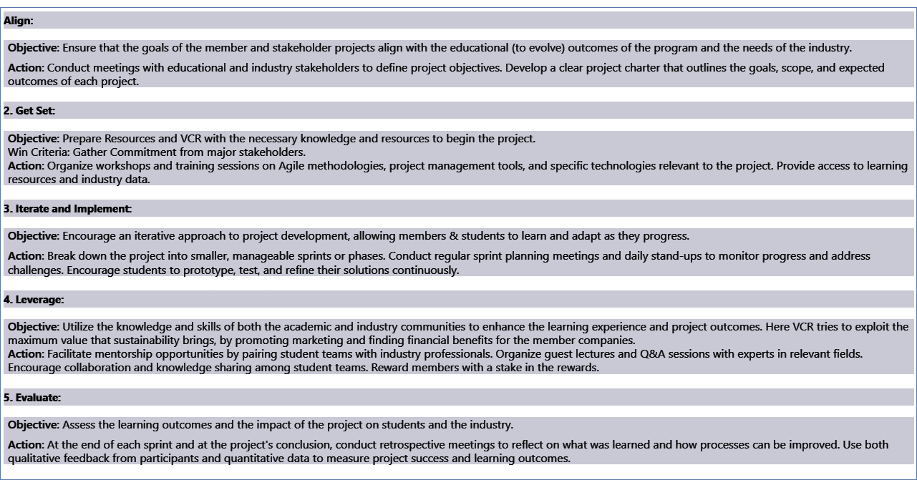

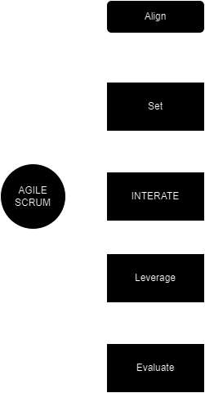

Workshop and Tool Development

Action: Prepare and offer workshops tailored to partners and members, focusing on supply chain sustainability.

## Innovation: Develop simulation tools to analyze and improve supply chain sustainability, enhancing our value proposition to partners and stakeholders.

Education and Capacity Building:

Immediate Actions:

Develop a curriculum outline for the first sustainability workshop, focusing on practical tools and strategies.

Partner with a local university or sustainability expert to co-deliver the workshop.

Process:

Begin marketing the workshop to industry partners and through social media.

Schedule and conduct the first workshop by the end of Month 3.

## Phase 3: Expansion and Reach

Research and Development:

Immediate Actions:

Identify top 5 sustainability challenges in current supply chains through a quick survey among stakeholders.

Launch a pilot research project focused on the most cited challenge.

**Process:**

Weekly progress checks.

Draft preliminary findings for internal review by the end of Month 3.

## Fase 1: The startup

We can start scouting for opportunities as soon as we have decided on the vision, value proposition, goals, and the memorandum of the organisation; There is no need to wait for anything else.

Action: Craft a collective memorandum to communicate our mission.

A. Partner Selection & Opportunities :  
  
 An opportunity can be in the form of a grant, or a potential supplychain for improvement. Finding these provides potential funding opportunities as well as potential partners selection criteria. Meanwhile we can start looking for potential partners.  
  
Partner Selection Steps:

Action: Categorize partners into diverse stakeholder groups.

There are partners that could yield new members (students), parters that yield new projects (companies, or government), partners that could give us tools, partners that could give us funding, partners that could give us tools.

Action: Identify partners for students, projects, tools, and funding.

B. Organisational Structure  
The buildingblocks of an organisation need to be in place before we can start to onboard more members or approach partners. We need to know what to say to them or what they should do.

Action: Create essential digital assets like flyers, a website, a notion page or planning page, a forum, a chat program, a code repository. See Diagram.

Action: Start building a strong online presence, including LinkedIn.

Action: Set up a minimal organizational structure, including automated onboarding processes.

This includes specialised QR codes and links for recruitment “funnels”, specialised on the type of potential member (partners, students and external partners have different administration processes).

Fase 2 – Reach

We need to develop communication materials:

Action: Create dedicated slide decks for conveying ideas, recruitment, partnerships, and engagement with companies.

Action: Develop a minimum approach for each potential partner.

Action: Start giving workshops to organisations.

Action: Start giving classes and guest lectures and spread the word, and recruitment links.

4. Organizational Structure:

5. Regular Meetings:

Action: Schedule regular meetings for discussing day-to-day operations, task delegation, and progress updates.

6. Immediate Recruitment:

As soon as we have minimum organisation structure, specifically the onboarding process, we can start recruitment. We do not need to wait to get partners, to onboard new members, they can help us get new partners, and as outlayed in the strategic plan, projects is only a part of what members do in Value Chain Rebels.

Action: Start recruiting members immediately; they can help attract partners, as outlined in our strategic plan.

7. Prepare Workshops:

Action: Develop workshops to offer to partners and members.

9. Simulation Tools:

Action: Create tools for simulating supply chains with sustainability factors.

Expected Outcomes:

Enhanced partner engagement and categorization.

Strong online presence to attract partners and members.

Clear communication materials to convey our mission.

Effective approach for engaging with potential partners.

Established organizational structure for smooth operations.

Regular meetings to maintain alignment and progress.

Active recruitment of members.

Developed workshops to offer.

Simulation tools for supply chain sustainability.

Key Performance Indicators (KPIs):

Number of partners engaged per category.

Website traffic and engagement metrics.

Feedback and responses from communication materials.

Conversion rate of potential partners.

Organizational structure setup timeline.

Meeting attendance and agenda adherence.

Number of recruited members.

Workshop participation and impact assessment.

Functionality and relevance of simulation tools.

Start with a selection of potential partners, but devide them into groups so that you have diverse stakeholders.

Make sure we have a flyers, a landing page (website) , some video content, and all the basics down (linkedin presence, etc).

We need to write memorandum, a collective statement what we’re doing, to broadcast.

A slide deck with the general idea  
A slide deck for recruitment  
A slide deck for partners  
A slide deck for companies

A plan of approach for each potential partner

We need to setup minimum organisation structure, like the automated onboarding processes.

We need a schedule for regular meetings, for just talking about what we’re doing. Day to Day business, task deminiation.

As soon as we have minimum organisation structure, specifically the onboarding process, we can start recruitment. We do not need to wait to get partners, to onboard new members, they can help us get new partners, and as outlayed in the strategic plan, projects is only a part of what members do in Value Chain Rebels.

We need to have ready a couple of workshops to give  
  
We need to have tools for simulation  
  
We need to have simulations of supplychains with sustianbility factors

Wat moeten we doen om het strategische plan neer te zetten.   
Wat zijn de strategische doelen uitgewerkt in kleine stappen, met name de stappen om te komen tot de eerste cohort  
Hoe gaan we de cohort verbeteren naar de grotere organisatie.

Wat moeten we doen tussen nu en start om het te realiseren.

Value Chain Revolution (VCR) is committed to transforming global supply chains through sustainability and efficiency. Our operational plan is a strategic blueprint designed to foster innovation, collaboration, and continuous improvement across all facets of our organization. Central to our approach is the integration of key functions—Research and Development (R&D), Education and Outreach, Partnership Development, Technology and Innovation, Funding Acquisition, Operations and Project Implementation, Policy Advocacy, and Human Resources and Administration. Each plays a vital role in propelling us toward our sustainability objectives.

### Interconnected Functions

Our operational framework features several key functions, each interconnected to promote holistic progress:

**R&D adopts Agile Development** methodologies for swift innovation, allowing iterative refinement of sustainable technologies and practices.   
 Projects can be found here through the data gathering done, with CSS ICS and SCS (see annex A). This helps us identify potential high impact sectors, which is good for new project justification.

Education and Outreach utilizes Adult Learning Principles to craft programs that are engaging, relevant, and tailored to adult learners, ensuring impactful learning experiences.

By using workshops as ideation tools, we can create a solid “Problem definition” that has its roots in actual business needs.

Partnership Development employs Relationship Management strategies, emphasizing regular communication, mutual benefits, and collaborative planning to forge and sustain strong partnerships.

By keeping regularly in touch and specifically by employing the strategy of “Championing your Customer” – a.k.a paising everyone that *uses* VCR, we can create a lasting social “signal” that continuously provides us with more project, funding, member and idea opportunities.

External Influences and Methodologies

## We recognize the impact of external factors like market trends and environmental challenges. Utilizing PESTLE and SWOT analyses, we continuously assess the external environment to adapt our strategies accordingly.

## Operational Flow

Our operational flow begins with strategic planning, leveraging both internal capabilities and external insights. This informs our R&D efforts, which fuel our educational and outreach initiatives. Innovations from R&D lead to new partnerships and funding opportunities, all supported by robust operations and project implementation strategies. Insights gained across all functions inform our policy advocacy, ensuring VCR's mission progresses both internally and in the global arena.

## Approach

## VCR's approach is built on the premise that achieving sustainable change in supply chains requires a multifaceted strategy and that no initiative should be undertaken unless there is a potential business function. By organizing our efforts around key functions with specific, measurable outcomes, we harness diverse expertise and foster partnerships to drive innovation. Open communication and teamwork are paramount, ensuring that solutions and ideas are shared widely to stimulate innovation.

## VCR should not consider “carbon credits” or anything that doesn’t fall within the traditional value norms, to calculate its sustainability or effectiveness. These additional measurement tools are abstractions or incentives that can paradoxically have the opposite effect. Key and point: the nations with the strongest economies in the African continent, are those that received the least assistance. Nigeria, with a GDP of $514 billion, received an estimated $5 billion in aid, contrasting sharply with Malawi, which, despite receiving over $1 billion in aid—proportionally much higher relative to its economy—has a GDP of just around $12 billion

## Measuring Success

## Success is measured against the KPIs established for each function, providing a clear, quantifiable gauge of our impact. These KPIs reflect our progress in developing sustainable solutions, engaging educational programs, and building strong partnerships. Regularly reviewing these indicators helps us stay on course and adapt our strategies to meet challenges and seize opportunities.

# Budget and Financing

Placeholder

## Financial Planning

Placeholder

## Financing Strategies

Placeholder

# Risk Management

Placeholder

## Risk Analysis

Placeholder

## Mitigation Strategies

Placeholder

# Marketing and Outreach

Placeholder

## Target Audience Definition

Placeholder

## Marketing Strategies

Placeholder

## Communication Plan

Placeholder

# Evaluation and Improvement

How do we guarantee projects survive? That we improve? That we have a good reason to excist?

## Success Metrics

Placeholder

## Feedback Mechanisms

Improvement Process

# Employee Feedback & Action

How do we make sure that feedback is implemented? This chapter might seem irrelevant, but since VCR requires its members to do a lot of volunteering and activities out of passion, making sure that people are heard is of high importance.

## Feedback Collection Analysis

How, and when do we collect feedback?

## Feedback into Action

How do we make sure people are heard?

# Research and Development (R&D)

How are projects found? Which Projects are selected? And why? How is an effective solution guaranteed?

## Research Objectives

How will we know if we are successful?

## Research Process

Which methodology? What are the flows in the organization?

# Academic Programs and Curriculum

How do we serve the larger educational institutions? Which workshops are there? How do we train new members?

## Program Development

How do we create new Workshops and Training material?

## Teaching Methods

Which underlying methodology do we use?

# Student Affairs and Mentorship

How do we know that we complete good internships for students or other members that are coming here to learn? How do we do the paperwork? How do we keep in touch?

## Student / member Wellbeing

How we check if people are not feeling left out?

## Group Activities

Which group activities should we do to promote both fun and learning?

Example: Wolven: A game made to illustrate an informed minority will almost always win against a uninformed majority – Social Dynamics game that explains why “no one is dealing with the climate crisis”.

# Staff Policies and Faculty Development

Placeholder

## Recruitment and Retention

Placeholder

## Professional Development

Placeholder

# Compliance and Regulations

## Legal Compliance

GDPR compliance, ISO 27000

## Regulatory Strategies

How do we make sure that we can keep eachother private and still try to “look” for people.

ANNEX I :

**Value Chain Rebels** is an **unique** research lab as it has a **different value proposition:** Unlike commercial labs that often prioritize immediate profitability, potentially sidelining long-term sustainability, and university innovation labs hindered by funding limitations for groundbreaking projects, Value Chain Rebels redefines the game. We champion sustainabe impact as both a core valueand a catalyst for funding, a catalist for recruitment and social media as well as competative business advantage. **Focusing on** the pursuit of **immediate**, **impactful actions** for a sustainable future. This approach not only differentiates us but also drives our mission forward, leveraging short-term sustainability impacts as a strategic advantage.

* **Active National Monitoring:** We actively monitor and search for inneffective supplychains trough environmental impact or unsustainable markers[1]. This helps us select potential sectors for improvement, partners to engage with, and measure impact. Additionally we actively monitor for opportunities, like grants in combination with the partners that have joined our initiative.
* **Living Projects:** VCR is not a commercial enterprise and as such conducts research based on public opinion, with visibility as a key marker. Projects, “evolve”[2] to better themselves over time, measuring impact in supplychains can take long time after all.
* **Agile-Fast Pased Development:** At Value Chain Rebels we work try to maximize short-term sustainable impact, like we’re developing the next million euro application.
* **Sustainability as an Unfair Advantage:** At Value Chain Rebels, we believe in leveraging sustainability as a distinct competitive edge. **We actively explore opportunities rather than focusing on a single project**, such as advocating for favorable laws, legislation, subsidies, and trade barriers that incentivize sustainable practices. By creating an environment where adopting these best practices is not only responsible but also a smart business decision, we ensure that sustainability becomes a powerful driving force for our partners and the industry as a whole. This additionally doubles as a marketing strategy, projects will become commercial assets for logistics companies to aquire. As well as a recruitment strategy for partners, outlaying opportunity rather than fear.
* **Industry Collaboration**: We partner with companies to implement sustainable-developed solutions, enhancing supply chain stability and offering practical enchancement.
* **Advocacy and Thought Leadership**: Students and members disseminate their findings and advocate for sustainable practices through publications and presentations, influencing industry and policy.

### **Robust Partnership Networks**

VCR will develop strong partnerships with academic institutions, industry leaders, NGOs, and government bodies to complete it’s objectives. These relationships can provide resources, expertise, and real-world contexts for research, enhancing the relevance and applicability of findings and form the core of VCR. To be more effective, VCR should preform Identification, Engangement and formalization processes.

See Diagrams for proces steps.

Please see VCR list for a potential list of partners.

*Note: At the end of every project, extra attention should be given at assesing the impact of the project, the learnings and the use of the project. This is not just to measure our preformance of the group, but to buy-in futher to the next project.*

### **Innovative Research Infrastructure:**

Value Chain Rebels takes on some of the most formidable issues, which is part of our allure. To support our teams in tackling these challenges effectively, we are committed to providing them with the best tools available.

For an overview of the software and infrastructure for software development, and projectmanagement, please see annex C.

Ensuring Project Longevity and Visibility: Projects within VCR are designed for longevity and maximum visibility. To achieve this, we plan to implement virtual reality environments for project development and showcasing. These immersive digital worlds will not only facilitate project development but also enhance their visibility and impact.

See Example: <https://hubs.mozilla.com/wUmZ2Yy/strong-juicy-assembly/>

These “worlds” can be connected to eachother, providing a laberynt of knowledge, innovation and exploration.

Visibility as a Key Marker: Agile methodology emphasizes that increased project visibility enhances its success. To achieve this, all projects will be prominently showcased on our website, ensuring transparency in project processes for funding and social media purposes. It's important to note that projects may not always require funding, as a project could also encompass training initiatives.

How that could look like:

<https://www.notion.so/HecThaFood-Heck-tha-Food-Home-Dashboard-e7636673ad8f45db8990314fd20b1bfe?pvs=4>

Innovative Education Options:  
At VCR we're all about embracing an "Agile First" mindset, where we're quick to adapt and iterate in everything we do, from our projects to our educational programs. We also believe in the power of failing first, new methodologies coming out of the latest radical education approaches. We see our students not just as crucial contributors, deeply investing in their projects and lives to spark innovation and foster a sense of ownership. Our teaching philosophy is built on nurturing "Conscious Competence," where participants are not just proficient in their skills but also deeply understand their abilities and how to use them for real-world impact.

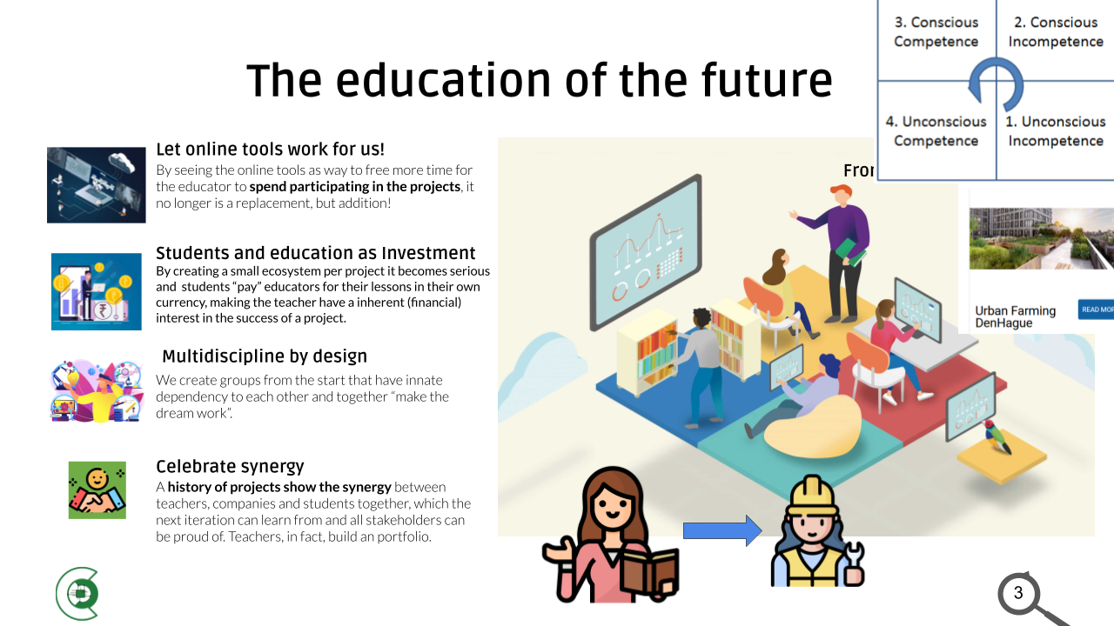

Recruitment Strategy

Our recruitment strategy focuses on diverse talent acquisition by offering realism-centric workshops, specialized classes, and insightful guest lectures. These educational initiatives are supported by a dynamic social media campaign emphasizing practical knowledge. We also actively engage with unconventional networks, such as DevCon, CCC, and LAG, to connect with radical thinkers and provide a platform for open expression. This approach helps us attract 'Crazy Professors and Alternative Thinkers' who bring creativity and critical thinking to our team, essential for driving innovation

Onboarding and Offboarding

Members (which include students) join VCR for a limited period, usually 6 months (an internship). We do not onboard or offboard members, just for a specific project, **so students don’t need to have a specific project ready,** to join. This does not just insure honest commitment to projects from members (preventing students from just “forcefully” selecting a project) but also flow trough the organisation, as well as training opportunities. Additionally, this will make projects created with VCR independant from it’s founding members, least projects tend to stop or lose sigificant momentum at each major cycle.

Educational Justification Note: At Value Chain Rebels, students are immersed in a unique learning environment where they function as "lab members." Unlike traditional educational settings, here they engage in projects with a dynamic approach, akin to real-world labs, software development agencies, or consultancy firms. This hands-on experience allows them to develop skills as independent researchers, innovators, and project managers, even though they may participate in varying numbers of projects, mirroring the unpredictability of professional scenarios.

Our onboarding ensures new members are ready and integrated from the start. It includes clear pre-start communication, an immersive introduction to our mission and team, customized skill training, mentorship for support and growth, and project alignment to match interests and expertise.

*Potential Partners are currently, Hogeschool Utrecht, 2Tokens, Toekomst school, To drive sustainability we need to improve value chains. To improve value chains we need to mobilize willing consortia. To create willing consortia we need the drive of changemakers. Students often want to be the changemaker but do not know how. For students to be effective they need access to knowledge, support and guidance. VCR develops the support mechanism to turn students into effectively taking up this role of changemaker. VCR supports access to knowledge, onboarding programs and community building*

*>> Creer de omgeving waar studenten kunnen triven om de supplychains te herorganiseren.*  
*> Wat we voor ogen hebben om te om de Supplychains te veranderen (Met studenten)*  
*> Samenwerkings positie*  
*> Cyclus het onboarden, managen, en offboarden van studenten. Wat hebben wij als mechanmisme voor nodig. Om de ketens te verbeteren.*   
*> tools, AI.*

*How do I find Problems, How do I contract it, How do I tackle it, and how do we make sure projects survive. >> Translate everything to Buttel points.*

* *Problem Definition : How do we find problems: Why did we take PFAS*
* *How are we going to Organize this: How does this look like*
* *How do we ensure that within 6 months a group of students and experts to get a successful project*

*Note: Pay extra attention to the structure of the Chapter, What are the minimum core things > 10 bullet points what the strategic plan is.*

*“We don’t want to tackle problems alone so that we can put students in the driving seat.*  
*How do we find the problems > Fase 2: How do we organize it that the problem is tackled the best, how does that look like.*

### Integration of Sustainability Metrics as a solution metric

Develop and integrate Long-Term Vision

## VCR envisions a future where global supply chains are not only efficient and profitable but also resilient, sustainable, and ethical. By adding extra value through sustainable and good practices, VCR aims to create a ripple effect that transforms global supply chain dynamics, making sustainability a cornerstone of business operations worldwide. Through collaboration, innovation, and advocacy, VCR is dedicated to leading this transformative journey, ensuring that supply chains contribute positively to the planet and its people for generations to come."

# ANNEX A

### Formula for Prioritizing Sustainable Supply Chains

Given the complexity and variability of supply chains, a composite score can be calculated using available ESG metrics. This score can help VCR identify which supply chains have the greatest potential for sustainability improvements. The formula integrates three main components: Environmental Impact (EI), Social Responsibility (SR), and Governance Quality (GQ).

### Step 1: Identify Data Sources

## Environmental Impact (EI):

Data Source: Corporate sustainability reports, environmental impact databases like the Global Reporting Initiative (GRI) database, and environmental data platforms such as the Carbon Disclosure Project (CDP).

## Metric: Carbon emissions (CO2e), water usage, waste generation.

Social Responsibility (SR):

Data Source: Social responsibility indices, labor rights organizations' reports, and corporate social responsibility (CSR) sections in annual reports.

Metric: Employee welfare scores, community impact assessments, supply chain labor practices.

Governance Quality (GQ):

Data Source: Governance reports, ESG rating agencies (e.g., MSCI, Sustainalytics), and public disclosures on corporate governance practices.

Metric: Board diversity, anti-corruption measures, ethical sourcing policies.

Step 2: Calculate Composite Sustainability Score (CSS)

The Composite Sustainability Score (CSS) for each supply chain can be calculated by weighting and summing the normalized scores of the three components:

$$CSS = w_{EI}* EI_{score}+ w_{SR}* SR_{score}+ w_{GQ}* GQ_{score}$$

Where:

CSS is the Composite Sustainability Score

w_EI, w_SR, w_GQ represent the weightings assigned to each component (Environmental Impact, Social Responsibility, Governance Quality) based on VCR's strategic priorities. You will replace these with the specific weight numbers you've assigned.

EI_score, SR_score, GQ_score are the normalized scores for each component, calculated from your data sources. These scores should be normalized to a scale from 0 to 1.

## Step 3: Prioritize Supply Chains

Supply chains with higher CSS indicate a greater potential for sustainability impact and improvement. VCR can prioritize these supply chains for interventions, partnerships, and sustainability projects.

## Implementation

**Data Collection**: Gather data for EI, SR, and GQ from the identified open sources for each supply chain under consideration.

**Normalization and Scoring**: Convert the collected data into normalized scores on a scale from 0 to 1.

**Weighting and Calculation**: Apply the formula to calculate the CSS for each supply chain.

**Prioritization**: Use the CSS to identify and prioritize supply chains for sustainability initiatives.

### Approach Using Trase and Vizzuality Data

#### Objective

To evaluate supply chains based on their environmental sustainability, focusing on indicators such as deforestation, greenhouse gas emissions, and the sustainability of commodity trade.

#### Data Sources

1. **Trase (Transparency for Sustainable Economies)**: Provides insights and analysis on the sustainability of commodity trade, including data on deforestation linked to specific commodities and supply chains.
2. **Vizzuality**: Offers datasets and software tools that map supply chains and calculate the impacts of environmental indicators, including deforestation and greenhouse gas emissions.

#### Formula for Evaluating Supply Chain Sustainability (SCS)

T evaluation can be based on key indicators such as deforestation risk and greenhouse gas (GHG) emissions associated with a supply chain. The formula could look like this:

SCS=1 / Deforestation Risk Score+GHG Emissions Score​

Where:

* **Deforestation Risk Score (DRS)**: Derived from **Trase**, measures the risk of deforestation associated with a particular supply chain or commodity. The higher the score, the higher the risk.
* **GHG Emissions Score (GHGES)**: Calculated based on data from **Vizzuality** or similar sources, represents the total GHG emissions associated with the supply chain. The higher the score, the higher the emissions.

#### Implementation Steps

1. **Identify Supply Chains**: Select the supply chains you wish to evaluate, focusing on those critical to your operations or those in regions known for environmental risks.
2. **Collect Data**:
   * Use Trase to gather data on deforestation risk associated with your selected supply chains.
   * Utilize Vizzuality’s datasets or similar tools to assess the GHG emissions of these supply chains.
3. **Calculate Scores**:
   * Assign a Deforestation Risk Score based on the extent of deforestation risk identified.
   * Assign a GHG Emissions Score based on the total emissions calculated.
4. **Evaluate SCS**: Apply the formula to each supply chain to determine its Sustainability Score. Lower scores indicate higher sustainability potential due to lower deforestation risks and GHG emissions.
5. **Prioritize**: Supply chains with the lowest combined risk and emissions scores should be prioritized for sustainability initiatives, as they represent the best opportunities for impactful environmental improvements.

### Approach for Identifying Suboptimal Supply Chains

#### Objective

To identify suboptimal supply chains where the introduction of good practices can enhance efficiency, reduce waste, and lower costs, with sustainability improvements as a natural consequence.

#### Data Sources and Metrics

1. **Operational Efficiency**: Look for data indicating long lead times, high variability in supply chain processes, and low inventory turnover rates.
   * **Data Source**: Industry reports, company financial reports available on platforms like EDGAR (for US companies), and supply chain management journals.
2. **Waste Levels**: Identify supply chains with high levels of waste, including excess inventory, high defect rates, and significant unused resources.
   * **Data Source**: Sustainability reports published by companies, research articles, and databases like the Global Reporting Initiative (GRI).
3. **Cost Metrics**: Focus on supply chains with high operational costs relative to industry benchmarks, including logistics costs, inventory carrying costs, and cost of quality.
   * **Data Source**: Industry benchmark reports, open financial databases, and logistics studies.

#### Formula for Identifying Suboptimal Supply Chains (ISC)

To quantify the suboptimality of a supply chain, we can use a composite score that considers efficiency, waste, and cost metrics:

Where:

* W1,W2, ​ W3 are the weightings assigned to each metric based on their perceived impact on supply chain performance.
* Each score is normalized on a scale from 0 (optimal) to 1 (highly suboptimal).

#### Implementation Steps

1. **Data Collection**: Gather data for the selected metrics from the identified sources for each supply chain under consideration.
2. **Score Calculation**:
   * **Operational Efficiency Score**: Higher scores for longer lead times and lower inventory turnovers.
   * **Waste Level Score**: Higher scores for higher levels of waste and defects.
   * **Cost Metric Score**: Higher scores for costs significantly above industry benchmarks.
3. **Evaluate ISC**: Apply the formula to calculate the ISC for each supply chain. Higher scores indicate supply chains that are more suboptimal and, therefore, have greater potential for improvement through the implementation of good practices.
4. **Prioritize**: Supply chains with the highest ISC scores should be prioritized for interventions. These are the supply chains where improvements in efficiency, waste reduction, and cost management can significantly increase value and lead to sustainability benefits.

ANNEX B:  
  
**Operational Plan Overview**

### Strategic Planning and Decision Making

**Objective**: To steer VCR towards achieving its mission through effective strategy and decision-making.

**KPI**: Achievement rate of strategic goals within the set timeframe.

**Function**: Guides the overall direction and strategy of VCR, integrating sustainability deeply into supply chain operations.

**Key Roles:**

**Executive Director**: Sets strategic priorities and leads the organization.

**Strategy Analysts**: Conduct market and sustainability trend analyses to inform strategic decisions.

**Tasks**:

Develop and periodically review the strategic plan.

Identify and prioritize areas for sustainability impact within supply chains.

### Research and Development (R&D)

**Objective**: To innovate and develop solutions that enhance the impact of good practices in supply chains, thereby transforming them into models of sustainability and efficiency.

Key Roles

R&D Director: Leads the R&D department, setting research priorities that align with VCR's mission to enhance the impact of good practices in supply chains.

Sustainability Research Scientists: Conduct research focused on identifying, developing, and refining good practices that can significantly improve supply chain sustainability.

Innovation Engineers: Design and prototype technologies and methodologies that operationalize research findings into practical solutions for supply chains.

Project Managers (R&D): Oversee R&D projects from inception through completion, ensuring they stay on track, within budget, and achieve desired outcomes.

Tasks

Research Identification: Identify areas within supply chains where the introduction or enhancement of good practices could lead to significant sustainability improvements.

Solution Development: Develop innovative solutions and methodologies that can be implemented in supply chains to promote good practices, reduce environmental impact, and improve efficiency.

Prototyping and Testing: Prototype new technologies and processes, and conduct rigorous testing to ensure effectiveness and scalability.

Collaboration and Knowledge Sharing: Collaborate with academic institutions, industry partners, and other stakeholders to share knowledge, gather feedback, and refine solutions.

KPI

Number of Innovative Solutions Developed: Track the number of new solutions and methodologies developed each year that aim to enhance the impact of good practices in supply chains.

Impact of Implemented Solutions: Measure the tangible impact of implemented solutions on supply chain sustainability, efficiency, and resilience. SEE CSS SCS ICS -> ANNEX A

Adoption Rate by Industry Partners: Monitor the rate at which industry partners adopt the developed solutions, indicating the practical applicability and value of R&D outputs.

Publications and Patents: Count the number of research publications and patents filed, reflecting the innovative output and thought leadership of the R&D function.

### Education and Outreach

Objective: To raise awareness and educate stakeholders on sustainable supply chain practices.

KPI: Engagement level of educational programs and outreach initiatives.

Partnership Development

Objective: To build strategic partnerships that enhance VCR's impact and resource base.

KPI: Number of strategic partnerships formed.

## Technology and Innovation

Objective: To leverage technology in advancing sustainability within supply chains.

KPI: Implementation rate of new technologies in supply chain projects.

Funding Acquisition

Objective: To secure financial resources to support VCR's mission and projects.

KPI: Total funds raised versus target.

Operations and Project Implementation

Objective: To execute sustainability projects effectively within supply chains.

KPI: Success rate of implemented sustainability projects.

Policy Advocacy

Objective: To influence policy in support of sustainable supply chain practices.

KPI: Number of policy changes influenced or initiated.

Human Resources and Administration

Objective: To support VCR's operational needs and ensure a motivated, engaged team.

KPI: Employee satisfaction and retention rate.

### Promotion of Labor Practices (in the style of FORD)

## Simulate and talk about the effect of good practices across all supply chain levels. By ensuring fair wages, safe working conditions, on-time payments and respect for workers' **ford** showed us that output can increase and you can turn it into a significant advantage. We need to make sure that there are economic drivers to do ethical practices, otherwise we break “The social contract”. The story of Henry Ford illustrates exactly the paradigm of supply chain, hailed as an innovator for sustainable business practices, not a lot of people pay attention to the fact that he didn’t do it to be in the “moral right”. He did it, because it was an economic opportunity, and he did it, cold and calculating. He did it, to add more value to his products, his company, his consumer’s lives but especially to his bottom line.

### Circular Economy Adoption (in the style of ROCKERFELLER)

## Facilitate the transition towards a circular economy by encouraging the reuse, recycling, and repurposing of materials **and how this can be used for profit**. Use examples like Rockefeller and the “Queen of Trash” Zhang Yin. This effort seeks to minimize waste and promote the regeneration of natural systems, trough basic economics, thereby adding value to the supply chain while protecting the planet.

### Technology-Driven accountability (in the style of the VOC)

## Utilize advanced traceability technologies to bolster accountability within supply chains. This strategy empowers both consumers and businesses to hold entities accountable for their commitments and to their word. By ensuring that every step of the supply chain can be audited and verified, sustainable finance can start to take hold. By making the rules semi-equal for everyone, we can allow the supplychain dynamics to make the supplychain more stable and profitable.

Effectively VCR can become a 3rd party neutral distributor of supplychain software.

### Collabortive Innovation Platforms (in the style of a Library)

## Create education and information exchange between businesses, innovators, and researchers and specifical research institutions to develop new solutions for supply chains. These platforms will serve as incubators for ideas that can revolutionize supply chain practices, focusing on sustainability and social good. They should work as a traditional library, where you can come in and find information*, there might be someone to help you*, but the idea is that you can find it yourself, explore by yourself, and that each book, *should* do its own job of explaining itself.

ANNEX C:

|  |  |  |
| --- | --- | --- |
| Digital Tools and Platforms | Trello | Visual project management tool for organizing tasks and projects. |
| Digital Tools and Platforms | Asana | Project management software for team collaboration. |
| Digital Tools and Platforms | Jira | Project tracking tool for software development projects. |
| Digital Tools and Platforms | Amazon Web Services (AWS) | Scalable cloud computing services. |
| Digital Tools and Platforms | Google Cloud Platform | Cloud computing services for storage and computing power. |
| Digital Tools and Platforms | Microsoft Azure | Cloud computing service for building |
| Data Analytics Platforms | Apache Hadoop | Framework for distributed storage and processing of big data sets. |
| Data Analytics Platforms | Spark | Fast and general engine for big data processing. |
| Data Analytics Platforms | R | Statistical computing and graphics software. |
| Data Analytics Platforms | Python with Pandas and NumPy | Programming language with libraries for data analysis and manipulation. |
| Data Analytics Platforms | SPSS | Software for statistical analysis. |
| Data Analytics Platforms | Stata | Statistical software for data analysis |
| Data Analytics Platforms | Tableau | Data visualization tool for business intelligence. |
| Data Analytics Platforms | Power BI | Business analytics service for data visualization. |
| Data Analytics Platforms | Google Data Studio | Data visualization and reporting tool. |
| Global Research Networks Access | Google Scholar | Search engine for scholarly literature. |
| Global Research Networks Access | Web of Science | Comprehensive research platform. |
| Global Research Networks Access | Scopus | Abstract and citation database of peer-reviewed literature. |
| Global Research Networks Access | arXiv | Open access repository of scientific papers. |
| Global Research Networks Access | PubMed Central | Free full-text archive of biomedical and life sciences journal literature. |
| Global Research Networks Access | SSRN | Repository for research in the social sciences and humanities. |
| Training and Development | Coursera | Online learning platform offering courses from universities and colleges. |
| Training and Development | edX | Online learning platform offering courses from universities and colleges. |
| Training and Development | LinkedIn Learning | Online learning platform offering video courses taught by industry experts. |
| Training and Development | GoToWebinar | Tool for hosting webinars and online seminars. |
| Training and Development | WebEx | Video conferencing tool for webinars and online meetings. |
| Innovation Incubators | IdeaScale | Idea management software to capture and develop new ideas. |
| Innovation Incubators | Brightidea | Innovation management platform to collect and implement ideas. |
| Innovation Incubators | Adobe XD | Tool for designing |
| Innovation Incubators | Figma | Interface design tool with real-time collaboration. |
| Innovation Incubators | InVision | Prototyping and collaboration tool for designers. |
| Sustainability Integration | Siemens Building Technologies | Energy management systems for optimizing energy use. |
| Sustainability Integration | Honeywell Building Solutions | Technology and services for sustainable building operations. |
| Sustainability Integration | Waste Management Software | Software for efficient waste handling and recycling. |
| Sustainability Integration | RecycleTrack Systems | Technology-driven waste and recycling management service. |
| Ethical Research Practices | IRBNet | Web-based solution for research ethics compliance. |
| Ethical Research Practices | Mentor IRB | Ethics compliance software for managing research ethics submissions. |
| Ethical Research Practices | ProtonDrive | Secure cloud storage service for data protection. |
| Ethical Research Practices | Tresorit | Secure cloud storage for confidential documents and data. |
|  |  |  |
|  |  |  |
|  |  |  |
| ANNEX G:  ANNEX D: |  |  |
|  |  |  |
|  |  |  |
|  |  |  |
|  |  |  |

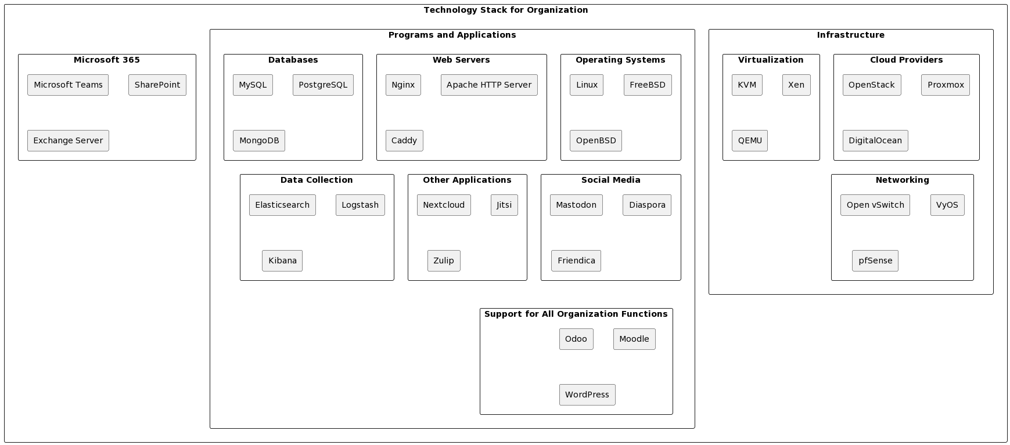

1. comprehensive metrics into supply chain operations which are to be used to select projects **ISC SCS CSS** [See Annex A], enabling businesses to measure and understand their environmental impact accurately and enabling VCR to select projects with the most potential impact. This initiative aims to make sustainability a quantifiable and actionable goal within supply chains.
2. comprehensive metrics into supply chain operations which are to be used to select projects **ISC SCS CSS** [See Annex A], enabling businesses to measure and understand their environmental impact accurately and enabling VCR to select projects with the most potential impact. This initiative aims to make sustainability a quantifiable and actionable goal within supply chains.